FUNDING PROGRAMME FOR THE GRANTING OF PATENTS

APPLICATION FORM
- INFORMATION ABOUT THE RESEARCHER/RESEARCH TEAM MEMBER AND THE RESEARCH CENTRE/UNIVERSITY

Name of the Research Centre/University where the researcher/research team conducts research:

Researcher/ research team members’ details. Please copy and fill in the fields (i) and (ii) for each member of the team:
- Personal details
Last Name
First Name
Name of father
National Identification Number
Tax Identification Number
Position held in the organisation/team
Job title
Phone
E-mail address

- Description of duties and contribution to the team (up to 100 words):

Company details (if applicable):
Name:

Legal status:

Founding date:

Address:

Tax Identification Number:

Website:

- INFORMATION ABOUT THE RESEARCH

Scientific field(s) of the research:

Subject and field of the research (up to 200 words):

Relevant publications (in case research result have been publicised):

- INFORMATION ABOUT THE INVENTION

Title of the invention:

Brief history of the research that led to the invention (up to 200 words):

Describe the problem or need that the invention aims to cover as well as its significance. If possible, use figures and references (up to 300 words):

Description of the invention (up to 500 words).
The description must indicate: a) what does the invention aim to achieve? b) how does it work or function? c) what are its technical characteristics? Include sketches of the invention if you deem fit:

Current stage of the invention (e.g. theoretical level, prototype, minimum viable product, initial commercial exploitation stage) and its commercial exploitation (up to 100 words):

Have you planned or are you planning further development of the invention? If so, explain (up to 200 words):

Describe the commercial exploitation prospects of the invention, referring to potential competitors within and outside Greece, and the comparative advantages of your invention (up to 300 words):

Describe how you expect your granting of the patent through this Programme to affect the invention’s commercial success (up to 200 words):

Please indicate the countries in which you wish your patent to be valid:

Describe how you plan to commercially exploit your invention, e.g. by creating a new company or granting commercial rights to an existing company (up to 100 words):
Have you filed a patent application in the past for another or a similar invention? If yes, please specify and describe the invention and the status of your application (up to 200 words):
Below is Appendix 1 where you complete the business plan for the existing company or the company you plan to establish for the commercial exploitation of your research results.

ANNEX 1: Business Plan

[Your company name here]
Your tagline
Business Plan
Prepared [date]

Contact Information
Jane Smith
jane@yourcompany.com
111-222-3333
www.yourcompany.com
1234 Main St.
Anywhere, OR 12345, USA

Table of Contents
Executive Summary 1
Opportunity 1
Expectations 1
Opportunity 2
Problem & Solution 2
Target Market 2
Competition 2
Execution 3
Marketing & Sales 3
Operations 3
Milestones & Metrics 3
Company 4
Overview 4
Team 4
Financial Plan 5
Forecast 5
Financing 7

Executive Summary

Opportunity

Problem Summary
INSTRUCTIONS: Describe very briefly why your business needs to exist. What problem do you solve for your customers?

Solution Summary
INSTRUCTIONS: Briefly summarize what your company does. The executive summary should be very short and you can go into more detail later in the plan.

Market
INSTRUCTIONS: Describe your target customer or market segments. Again, keep things very brief in the executive summary and add more detail later in the plan.

Competition
INSTRUCTIONS: Summarize your key competition. Who will your customers also consider?

Why Us?
INSTRUCTIONS: Write a brief overview of you and your team. Why are you the right people to build this business?

Expectations

Forecast
INSTRUCTIONS: Write a brief overview of your financial targets. How much do you plan to sell in the next year? What are your long-term sales goals?

Financial Highlights by Year
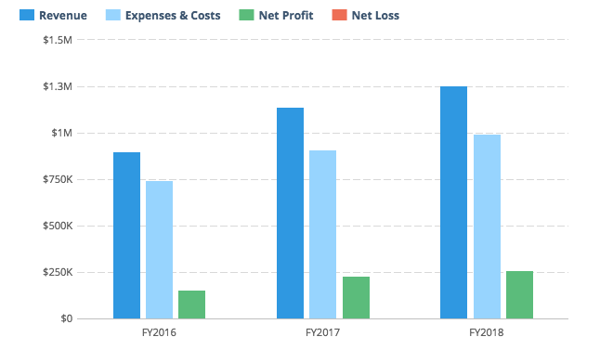
INSTRUCTIONS: Insert a chart of your key financial metrics here. Tools like LivePlan will do this for you automatically.

Opportunity

Problem & Solution

Problem Worth Solving
INSTRUCTIONS: Write a little more detail than you provided in the Executive Summary about the problem you are solving. What do your customers need? Do they need a better product, a cheaper product, or just a store in a better location? Describe why customers will want to buy from you.

Our Solution
INSTRUCTIONS: Provide additional detail, beyond what you wrote in the Executive Summary, about your product or service. What is unique and special about your company that’s going to set it apart from the competition?

Target Market

Market Size & Segments
INSTRUCTIONS: Describe your key customers – who they are and what their key attributes are. If your company is targeting multiple customer groups (also called ‘segments’), describe each group here. If you can, include details about how many people are in each segment and how large the total market is.

Competition

Current Alternatives
INSTRUCTIONS: Describe your current competition. What products and services are people using instead of yours?

Our Advantages
INSTRUCTIONS: Explain why your product or service is better than the others. Also, be sure to describe any competitive advantages you may have, such as a patent or other unique component to your business.

Execution

Marketing & Sales

Marketing Plan
INSTRUCTIONS: Explain how you plan on getting the word out about your product to your target market(s). Will you use advertising? Perhaps you are developing a content marketing strategy. Whatever your marketing plans may be, describe them here.

Sales Plan
INSTRUCTIONS: If your company relies on sales people to close sales deals, you need a sales plan. Your sales plan should explain how you convert people who express interest in your product or service into paying customers. If you are opening a food truck, this section is less important and you can consider removing it. However, if you are starting a sales-heavy business like enterprise software or a car dealership, then you need to document how you will nurture leads and close deals.

Operations

Locations & Facilities
INSTRUCTIONS: Describe your company’s physical locations. This might be your office, store locations, manufacturing plants, storage facilities — whatever is relevant to your business. How much space do you have available, and how well will it meet your current and future needs?

Technology
INSTRUCTIONS: Describe any important software, hardware, or other information technology that you use now or plan to use later to operate your business. That might include a point-of-sale system to take payments, an e-commerce engine for your website, a CRM solution for managing your pipeline, marketing tools for generating leads, and so on.

Equipment & Tools
INSTRUCTIONS: List any specialty equipment that you have or plan to acquire to do your work. This is an important component of the business plan for many industrial companies.

Milestones & Metrics

Milestones
INSTRUCTIONS: List your key milestones and the dates that you hope to accomplish them by. If you’ve already accomplished key goals for your business, list them here as evidence that your business is getting traction – in other words, it’s getting positive attention from potential customers.

Key Metrics
INSTRUCTIONS: Explain which performance metrics are most important for understanding how your business is doing. What does success mean for you, and how will you know it when you see it?

Company

Overview
INSTRUCTIONS: Use this area to specify who owns your company. If there are multiple owners, describe each of them and how much of an ownership stake they have. Also, identify your company’s legal structure. Is it a sole proprietorship — that is, just you working for yourself? Or a partnership, such as a limited-liability corporation (LLC) or partnership (LLP), where the profits pass through to the partners involved? Or a nonprofit organization? Or a proper S- or C-type corporation with its own tax obligations and the rest?

Team

Management Team
INSTRUCTIONS: List the members of the management team, including yourself. Describe each person’s skills and experience and what they will be doing for the company. It’s OK if you don’t have everyone for a complete management team yet. In that case, make sure to identify gaps in your team that you intend to fill over time.

Advisors
INSTRUCTIONS: Describe any mentors, investors, former professors, industry or subject-matter experts, knowledgeable friends or family members, small-business counselors, or others who can help you as a business owner.

Financial Plan

Forecast

Key Assumptions
INSTRUCTIONS: Describe how you came up with the values in your financial forecast. Did you project your revenue based on past results, market research, your best guess at how many people who visit your store and what percentage of them might buy, or some other method? What kind of growth are you assuming? What are your key hires and notable expenses? What level of profit do you expect to generate?

Revenue by Month
INSTRUCTIONS: Include a chart that shows your projected revenue. A tool like LivePlan can help you create a chart like this and automatically include it in your business plan.

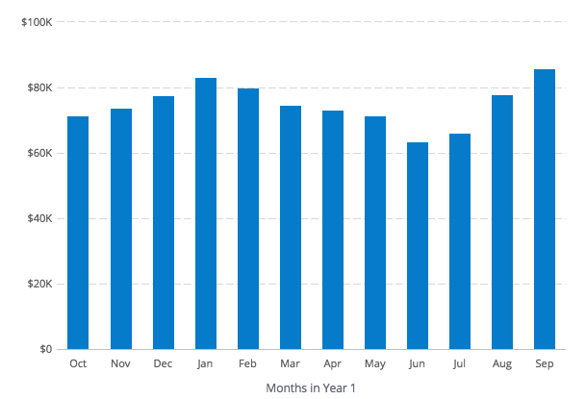

Expenses by Month
INSTRUCTIONS: Include a chart that shows your projected expenses. A tool like LivePlan can help you create a chart like this and automatically include it in your business plan.

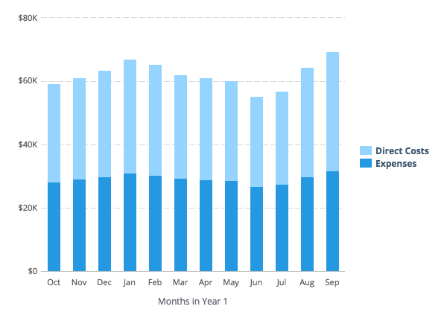

Net Profit (or Loss) by Year
INSTRUCTIONS: Include a chart that shows your projected expenses. A tool like LivePlan can help you create a chart like this and automatically include it in your business plan.

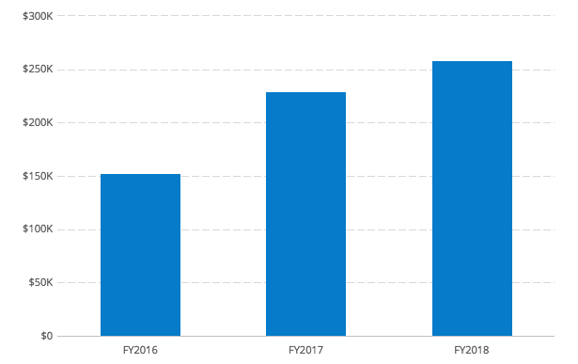

Financing

Use of Funds
INSTRUCTIONS: If your forecast includes loans, investments, or other financing, use this space to explain what you plan do with that money.

Sources of Funds
INSTRUCTIONS: Describe your financing plans. Are you investing your own money in the business? Do you have a credit card or line of credit? What other types of funds — personal or business loans, equity investments from others, etc. — do you expect to receive and when? If you do not have the full detail of future financing worked out yet, that is understandable. Just explain what you do know and when you expect to sort out the details.

